# **Table of Contents**

Table of Contents 1

Setting Up Terraform with VS Code on Windows 2

**Class discussion** 2

**Install Visual Studio Code** 3

**Install HashiCorp Terraform Extension** 3

**Download and Install Terraform for Windows** 4

**Configure AWS CLI** 7

**Create Terraform Files** 7

**Initialize and Apply Terraform Configuration** 9

**Cleanup** 11

# Setting Up Terraform with VS Code on Windows

## **Class discussion**

## **Install Visual Studio Code**

Go to the [Visual Studio Code website](https://code.visualstudio.com/). Download the installer for Windows.

Run the installer and follow the setup instructions.

## **Install HashiCorp Terraform Extension**

Open VS Code and navigate to the Extensions view. Install the **"HashiCorp Terraform"** extension.

## **Download and Install Terraform for Windows**

Visit the [Terraform downloads](https://developer.hashicorp.com/terraform/install). Download the appropriate Windows executable (.zip).

Extract the downloaded .zip file to a folder

Open the Start Menu, search for "Environment Variables,"

Under the **System Properties** window, click **Environment Variables**.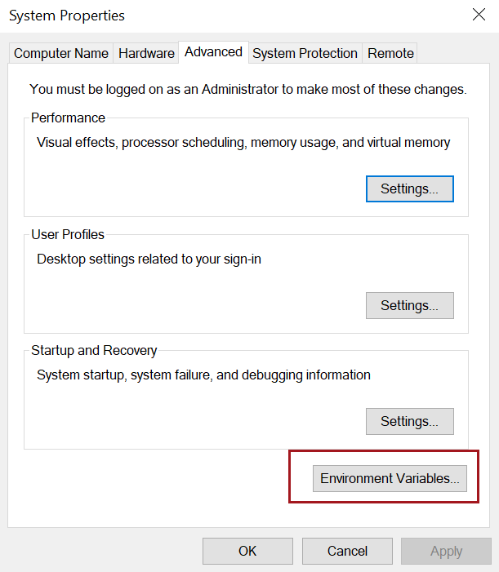

In the **System Variables** section, find and select the Path variable, then click **Edit**.

Click **New** and add the path to the Terraform executable (e.g., C:\terraform). Click **OK** to save and close all windows

Open a new Command Prompt or PowerShell window and type terraform -version. **Restart your system**

## **Configure AWS CLI**

Install the AWS CLI from the [official website](https://docs.aws.amazon.com/cli/latest/userguide/getting-started-install.html) and configure it using aws configure.

## **Create Terraform Files**

Create a new folder C:\terraform_practice. Open this folder in VS Code

Open gitbash terminal in VScode

Create another subfolder day01 in C:\terraform_practice

In the folder, create a file named provider.tf with following information

provider "aws" {

  }

In the same folder, create a file named main.tf. Add the following content. replacing <prt> with your initials to ensure the S3 bucket name is unique.

resource "aws_s3_bucket" "name" {

    bucket = "**prt**s3bucketterraform"

}

## **Initialize and Apply Terraform Configuration**

In Gitbash window, run the command to Initialize the working directory

cd day01

terraform init

Generate and review an execution plan which displays detailed summary of the resources Terraform will create.

terraform plan

Run below command to apply the configuration and create resources

terraform apply

Confirm the operation by typing yes

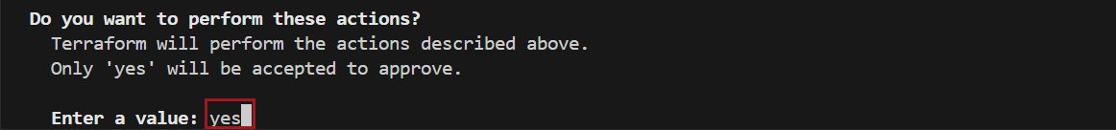

If everything looks fine, you will get following confirmation message

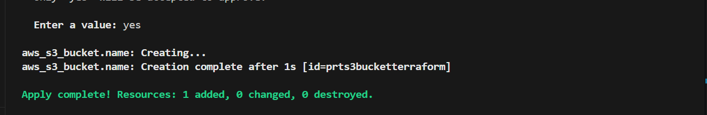

Log in to your AWS Management Console. Navigate to the S3 service and confirm the bucket is created.

## **Cleanup**

To clean up and remove the resources

terraform destroy

Confirm the operation by typing yes

